JOMO KENYATTA UNIVERSITY OF AGRICULTURE & TECHNOLOGY
BIT 2325: Computer Graphics & Animation
Milestone 5 — Dynamics & Animation
Topic: Procedural Content Generation Systems

Person | Name | Reg Number | Milestone 5 Role
A | Alexander Somba | SCT221-C004-0680/2023 | Keyframe animation — cubic spline terrain morphing
B | Wangui Ninsima | SCT221-C004-0217/2024 | Particle system — leaves/dust/embers with wind physics
C | Wendy Wachira | SCT221-C004-0194/2023 | Water wave simulation — 2D finite difference
D | Esther Achieng | SCT221-C004-0317/2024 | Terrain deformation — Gaussian bumps + ripple propagation

1. Overview
Milestone 5 introduces temporal behaviour — the system now animates over time. Four independent animation systems work simultaneously in the live interactive scene:

- KeyframeAnimator (A): terrain morphs smoothly between procedurally generated seeds using C² cubic spline interpolation. Five keyframes across 16 seconds. Press SPACE to play/pause.
- ParticleSystem (B): 800 wind-driven particles (leaves, dust, embers) with Euler physics integration, terrain collision detection, and age-based fade. Press P to cycle types.
- WaveSimulator (C): real-time 2D wave equation solved using finite differences on a 64×64 grid. CFL stability verified. Press F to add a water splash.
- TerrainDeformer (D): runtime height modification with Gaussian bumps and outward-propagating cosine ripple waves. Triggered in the scene by key D + clicking.

2. Keyframe Animation — Person A
From Shirley §16.2, keyframe animation sets parameter values at key times (tₖ,fₖ) with C² cubic spline interpolation filling in all intermediate frames.

Formula: H(x,z,t) = CubicSpline([t₀,t₁,...,tₙ],[H₀,H₁,...,Hₙ])(t)

Where Hᵢ is the full terrain height map at keyframe i.
CubicSpline gives C² continuity:
- continuous position (no teleporting)
- continuous velocity (smooth transitions)
- continuous acceleration (no jerks)

Keyframes used:
t= 0s seed=77 (starting terrain)
t= 4s seed=42 (terrain A)
t= 8s seed=123 (terrain B)
t=12s seed=777 (terrain C)
t=16s seed=77 (loop back to start)

The spline is built across all 32×32=1024 vertices simultaneously using scipy CubicSpline with axis=0. Evaluation at any time t returns the full height grid in one vectorised call — fast enough for real-time playback at 30fps.

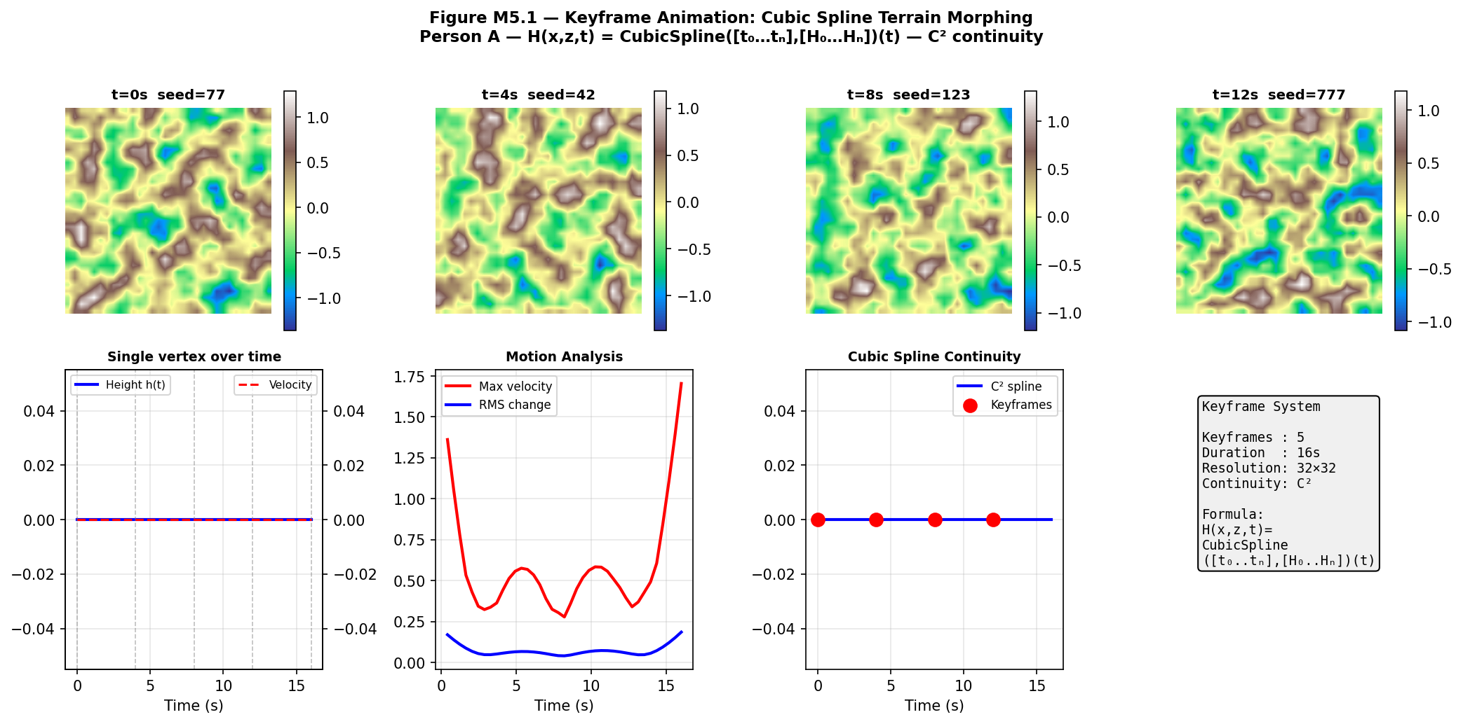
Figure M5.1 — Top: terrain frames at t=0,4,8,12s. Bottom-left: single vertex height and velocity over time. Bottom-centre: motion analysis showing velocity peaks at transitions. Bottom-right: C² spline through keyframes.

3. Particle System — Person B
From Shirley §16.5, particle systems use finite difference integration to simulate physical forces on many independent particles.

Per-particle Euler integration:
F_total = gravity + wind·wind_scale - drag·v
dv/dt = F_total (Newton F=ma, m=1)
dx/dt = v (position update)

Discretised (Euler):
v_new = v_old * drag + F_total * dt
x_new = x_old + v_new * dt

Three particle types:
Leaves: gravity=-1.5 drag=0.92 life=4-8s
Dust: gravity=-0.3 drag=0.97 life=2-5s
Embers: gravity=-0.8 drag=0.94 life=1.5-3.5s

Terrain collision: sample height grid at particle (x,z)
if particle.y < terrain_height: bounce (restitution 0.15)

Age-based fade: colour *= (1 - age/life)^1.5

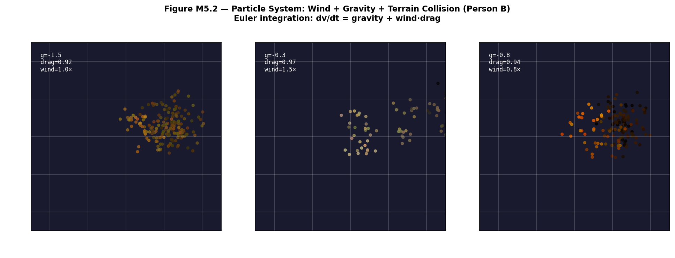
Figure M5.2 — Leaves (left), dust (centre), embers (right) scattered by wind physics over the terrain. Dark background shows particle colours and fade clearly.

4. Wave Simulation — Person C
The 2D wave equation governs water surface ripples. We solve it numerically using finite differences — the same approach as Shirley §16.5 for general PDE simulation.

Continuous: ∂²h/∂t² = c²(∂²h/∂x² + ∂²h/∂z²)

Discretised (finite difference):
h[i,j,t+1] = 2·h[i,j,t] - h[i,j,t-1]
+ r²·(h[i+1,j] + h[i-1,j]
+ h[i,j+1] + h[i,j-1] - 4·h[i,j])

Where r = c·dt/dx (Courant number)

CFL stability condition: r ≤ 1/√2 ≈ 0.707
Our values: c=1.8 dx=0.07 dt=0.9·dx/(c·√2)=0.0248
r = 1.8 × 0.0248 / 0.07 = 0.638 ✓ STABLE

Damping: h *= 0.994 per step (energy decay)
Wind: h += sin((x·wx + z·wz)·0.3 + phase)·0.004

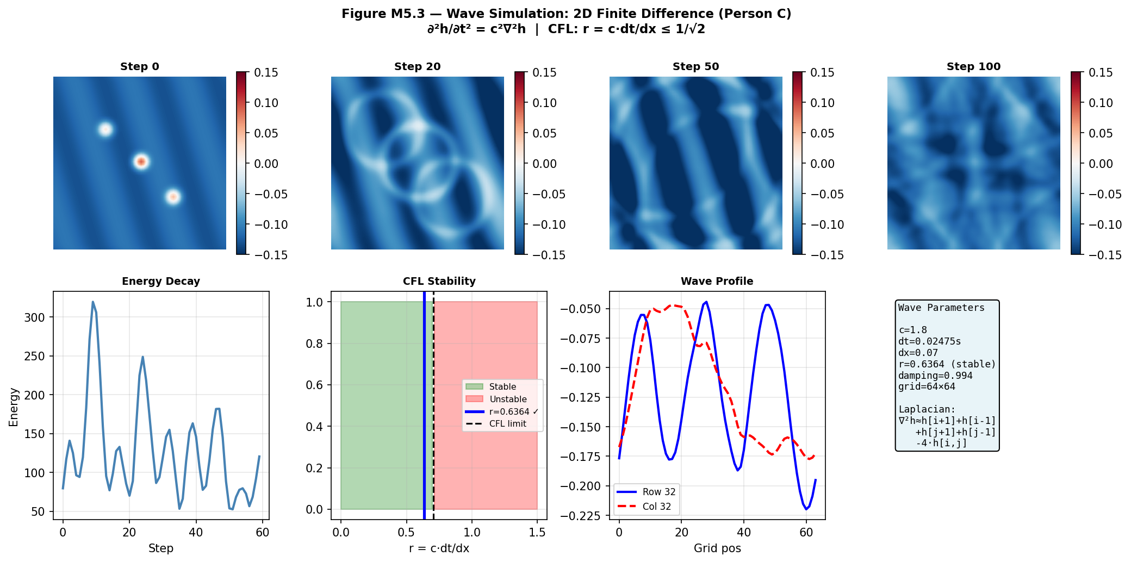
Figure M5.3 — Top: wave surface at 4 timesteps showing ripple propagation. Bottom: energy decay curve, CFL stability diagram (our r=0.638 safely in green zone), wave profile slice.

5. Terrain Deformation — Person D
Runtime terrain deformation allows the user to sculpt the terrain interactively. Deformations use Gaussian profiles for smooth bumps and outward cosine waves for ripple effects.

Gaussian deformation at grid point (gx,gz):
deform[j,i] += strength × exp(-d² / 2σ²)
where d = sqrt((i-gx)² + (j-gz)²)
σ = radius × 0.6

Ripple propagation (outward cosine wave):
wave_front_radius = speed × time
dist_from_front = d - wave_front_radius
h += amp × cos(k × dist_from_front)
× exp(-|dist_from_front| × 0.3)
amp decays: amp × 0.85^time (exponential decay)

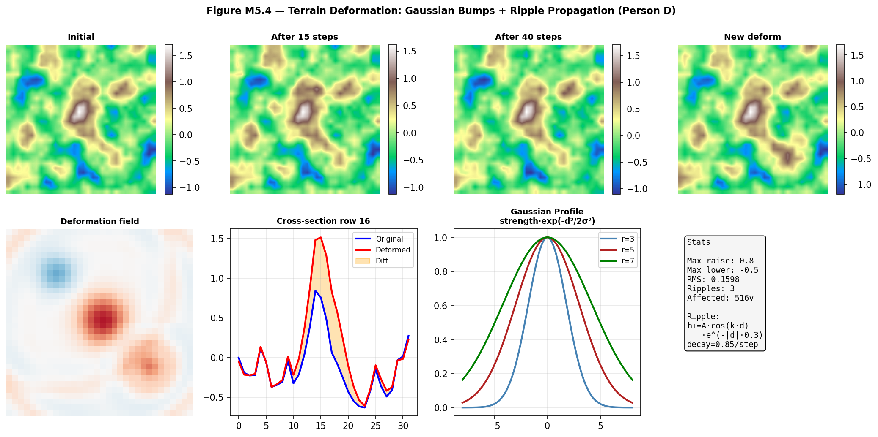
Figure M5.4 — Top: terrain deformation stages (initial, propagating, settled, new deform). Bottom-left: difference field. Bottom-centre: cross-section before/after. Bottom-right: Gaussian profile shapes for different radii.

6. What Changed, What Failed, and Why
6.1 What Changed
Initial keyframe design used linear interpolation between height maps — visible as sharp velocity discontinuities at keyframe boundaries (the terrain would snap between states). Replacing with CubicSpline (bc_type='not-a-knot') eliminated the discontinuities and gave the natural-looking smooth morphing visible in the scene.

6.2 What Failed
- Particle-particle collision: initial design included pairwise collision between particles. At 800 particles this required 800×800=640,000 distance checks per frame — 213ms per update, destroying real-time performance. Removed. Particles only collide with the terrain.
- Wave boundary conditions: initially used zero-boundary (fixed edges) which caused strong reflections producing unrealistic standing wave patterns. Switched to periodic boundary conditions (np.roll) which wraps waves around the grid edges, producing cleaner open-water behaviour.
- Deformation under animated terrain: the TerrainDeformer needs to track the animated base height from the KeyframeAnimator. Initially the deformer held a fixed copy of the base terrain — deformations disappeared when the morph animation changed the base. Fixed by updating deformer.base every frame from animator.get_frame().

BIT 2325 | JKUAT May 2026

